lab4 LLM Agent Workflow
- Request that passed the Gatekeeper (Request in the scope of cybersecurity)
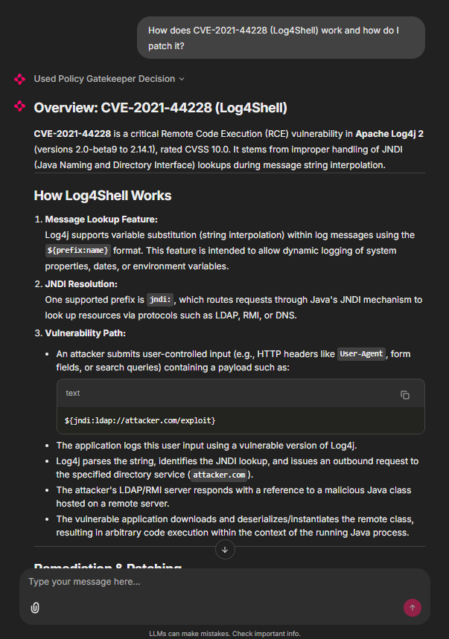
- Requests that didn’t pass the Gatekeeper (Not in the scope)
  - Unrelated to cybersecurity
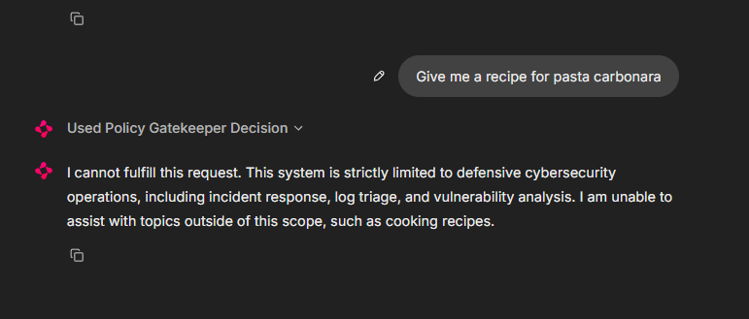
  - An attempt for jailbreak
